Buckeye Valley Family YMCA

Social Distancing Guidelines

Table of Contents

Ballpark Diagram…….………………….…………………………………….3

Social Distancing Guideline Overview……………..…....……....4

Park Entrance Guidelines………………………………..….............5

Park Exiting Guidelines…………….…………………...……...........6

Facility Guidelines………………..…………………..………………….....7

Game Play Guidelines...……………...…………………………….......8

Concession Stand Guidelines...………………….….………..……...9

Game Scheduling Guidelines....……………….………..…..…….10

Responsible Restart Ohio Baseball Guidelines………………..11

Responsible Restart Ohio Baseball Guidelines…...........…12

Ballpark Diagram

Social Distancing Guideline Overview

The following guidelines have been created by The Buckeye Valley Family YMCA (BVFYMCA) as suggested by The State of Ohio and The Licking County Health Department. These guidelines are to be utilized in everyday operation at Don Edwards Park 429 Ohio St. Newark, OH 43055 until otherwise noted by The State of Ohio, Licking County Health Department and The BVFYMCA. These guidelines are to be followed by all individuals on the premise of the facility, failure to comply with these guidelines can result in expulsion from the facility without refund. These guidelines can be altered and amended when deemed necessary by BVFYMCA staff in order to ensure the safety and well being of everyone in attendance.

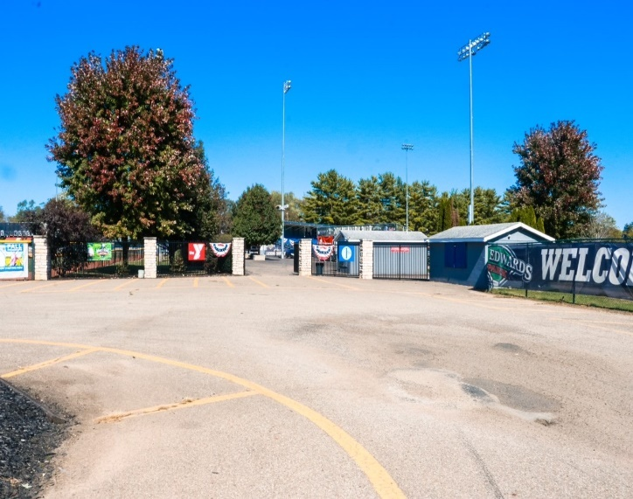
Park Entrance Guidelines
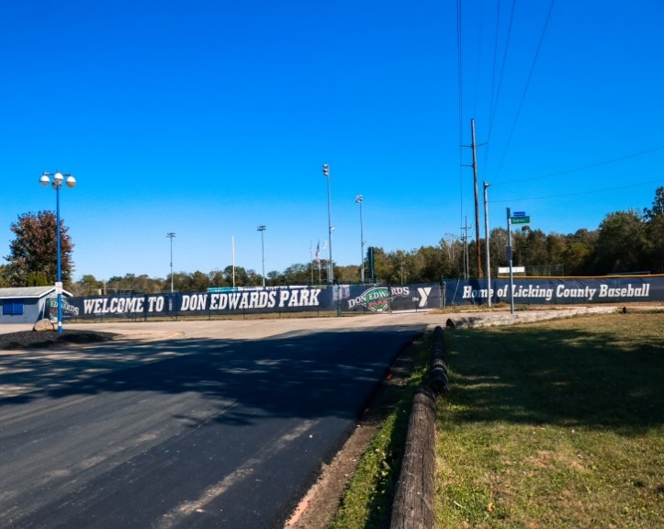
The red box shows where the double gate is when open
2
1

The following guidelines will be enforced regarding the admission of our facility.

- For entrance to LMH and McDonalds Field individuals will go through our main entrance located at the ticket booth which is marked as number (5) on the legend. Please stay on right side of dividers when entering and exiting facility.
- For entrance to All Weather Systems Field, Dormar Field and Energy Cooperative Field individuals will be permitted to drive their vehicle through our double gate entrance pictured above on Ohio St to there assigned field.
- When daily admission is charged individuals may enter the facility on foot or in their vehicle to the back fields. However, all admission fees will be charged on an individual bases regardless of how an individual enters the facility.
- Example 1: Two individuals walk in to view a game on LMH Field they will be charged individually at the daily rate.
- Example 2: Two individuals drive in together to view a game on All Weather Systems Field they will be charged individually at the daily rate.

Park Exiting Guidelines

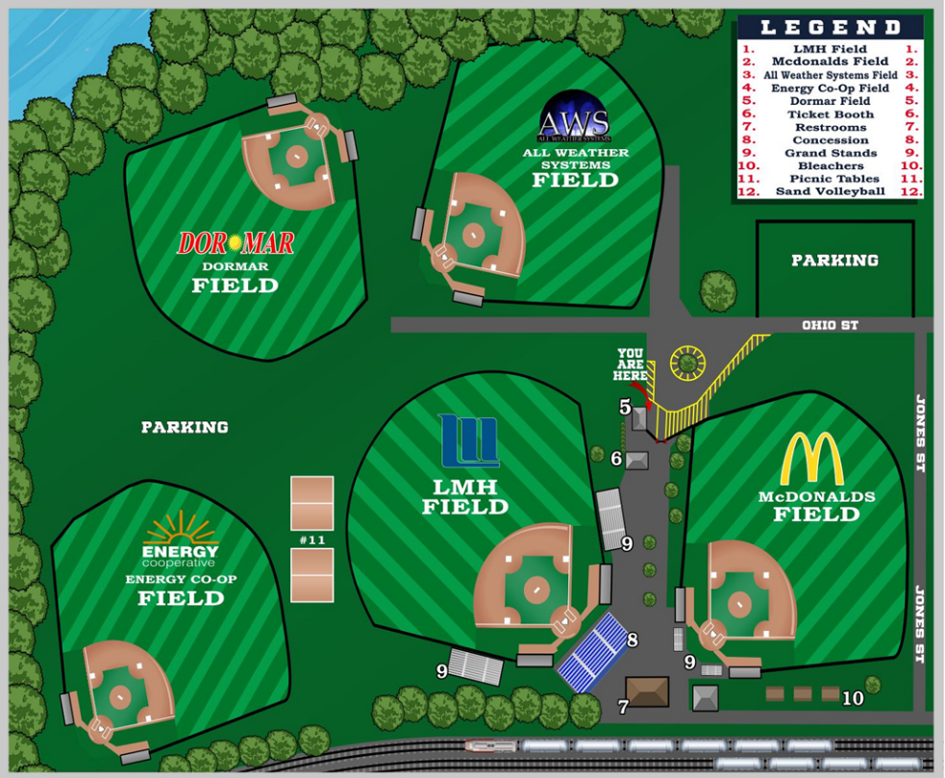

The following guidelines will be enforced regarding the exiting of our facility.

- NO RE-ENTRY will be permitted without the charge of an additional entry fee. All stamps and tickets have been eliminated to reduce contact.
- Fans watching games on our back fields are encouraged to park along the outfield fences and to watch the games inside their vehicles or in their own chairs, while maintaining the minimum 6-foot social distance from any other fans.
- When exiting the facility all cars will follow the gravel path around LMH Field that takes you behind our concession stand and out to Jones St. from there you will be able to turn back out on to Ohio St. NO CARS WILL BE PERMITTED TO ENTER THE FACILITY THIS DIRECTION, IT WILL BE USED STRICTLY AS AN EXIT TO CONTROL TRAFFIC FLOW. PLEASE REFER TO THE MAP AND RIDE LINE ABOVE FOR THE EXITING PATH.
Facility Guidelines
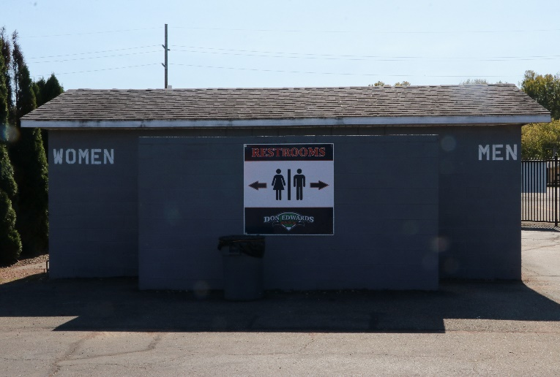
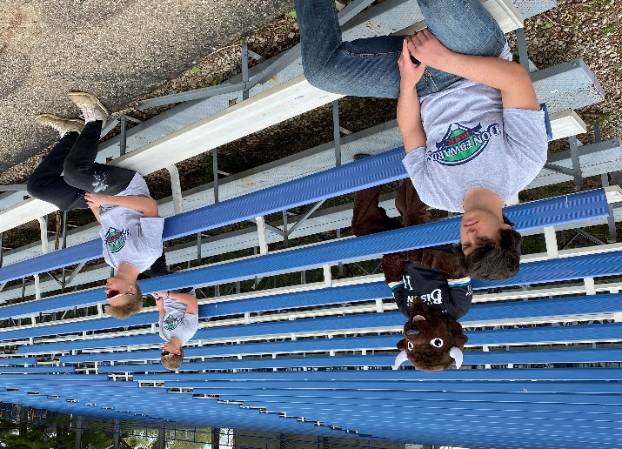

The following guidelines will be enforced throughout our facility.

- All fans must maintain a distance of at least 6-feet from one another.
- When utilizing our grandstand bleachers please sit at the pre-marked locations to ensure social distancing standards.
- When ordering food at our concession stand, please stand in the pre-marked locations to ensure social distancing standards.
- We ask that all fans that are willing to utilize personal face masks when appropriate.
- All picnic tables will be limited to groups of three (3) or less and we ask that the 6-feet social distancing is observed when in use.
- Our umpire room will not be available. Umpires are encouraged to keep all belongings in their vehicle.
- All Don Edwards Park staff will wear face masks and gloves where applicable.
- Routinely scheduled cleaning will take place of all common surfaces throughout the facility.
- Hand washing stations and or sanitizer will be available in bathrooms and porta-johns.
- Any individual entering our facility will be acknowledging they are symptom free and have done the self-assessments.
- Don Edwards Park will provide event details to the Health Dept for all events.

Game Play Guidelines

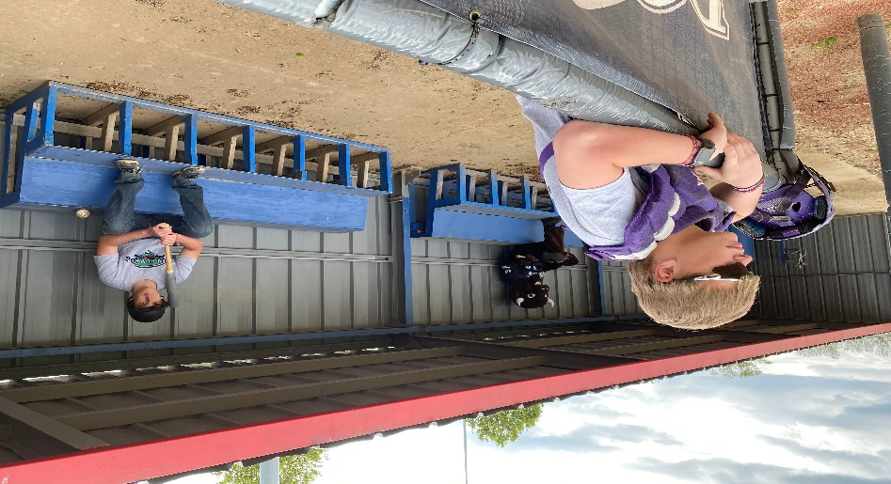

The following guidelines will be enforced regarding the game of play.

- All umpires and coaches are recommended to wear face masks.
- No pregame infield of any kind will be permitted. No player may enter a dugout until cleaned. To warm up for games place bag in outfield or along fence line and go to your respective outfield to warm up.
- Teams will be responsible for providing their own baseballs when on defense.
- A maximum of eight (8) individuals will be permitted in a dugout at any given time and must use marked spots on benches. They must maintain the 6 feet social distancing guidelines. Players are encouraged to bring chairs for sitting outside the fence.
- All additional players and coaches will be down their respective foul line on the other side of the fence, while maintaining the 6 feet social distancing guidelines.
- No team equipment or bat bags will be permitted inside the dugouts, but instead should be placed behind dugouts or along fence lines off the field of play.
- All athletes not actively participating in the game will be recommended to wear a face mask.
- No team water jugs will be provided. Individuals will need to provide their own. In addition, all forms of seeds and bubblegum will be prohibited, no spitting
- Coach/Umpire meetings will take place at home plate while maintaining 6 feet social distancing guidelines. Coaches will stand at the edge of the home plate circle on their respective sides, with the umpire standing on home plate.
- If at any point a coach needs to converse with an umpire 6 feet distance must be maintained at all times.
- Players are not permitted to gather at home plate in the event of a homerun or other exciting events.
- At the end of the game teams will line up on their respective foul lines and “tip their caps” to the other team instead of shaking hands. No team meetings, must exit the dugout and field immediately.
Concession Stand Guidelines
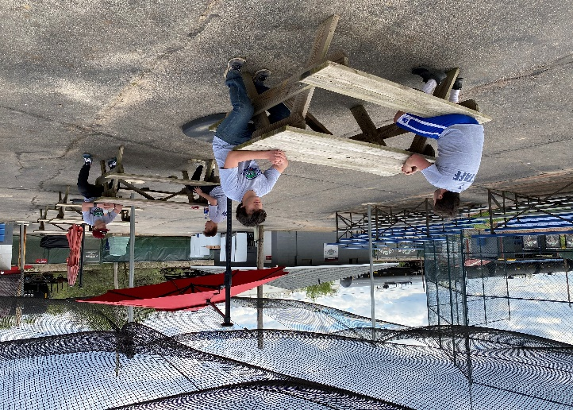
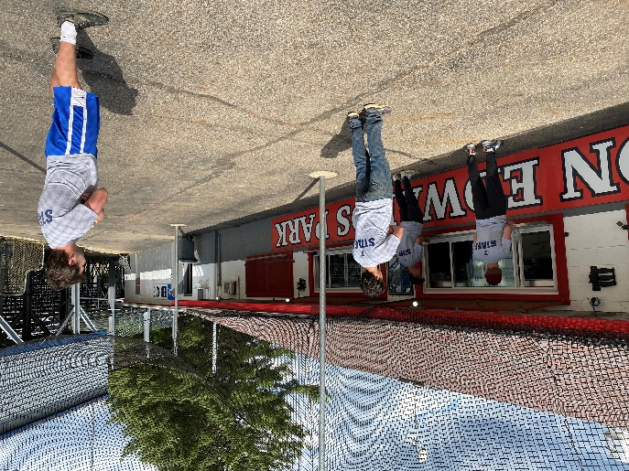

The following guidelines will be enforced at our concession stand.

- All Don Edwards Park staff will wear face masks and gloves where applicable.
- All staff will be screened for a temperature before clocking in for the day.
- When ordering food at our concession stand, please stand in the pre-marked locations to ensure social distancing standards.
- All picnic tables will be limited to groups of three (3) or less and we ask that the 6-feet social distancing is observed when in use.
- Fans will be encouraged to use our “Fan Food” app which allows them to create orders for pickup at the designated window, or delivery to the designated “Fan Food” pickup location on their respective field.
- Routinely daily cleaning throughout the concession stand facility will be doubled.
- Windows have been installed at our concession stand to limit exposure.
- We will continue to comply with the orders of the Licking County Health Department, along with adapt to any additional orders they might implement.

Game Scheduling Guidelines
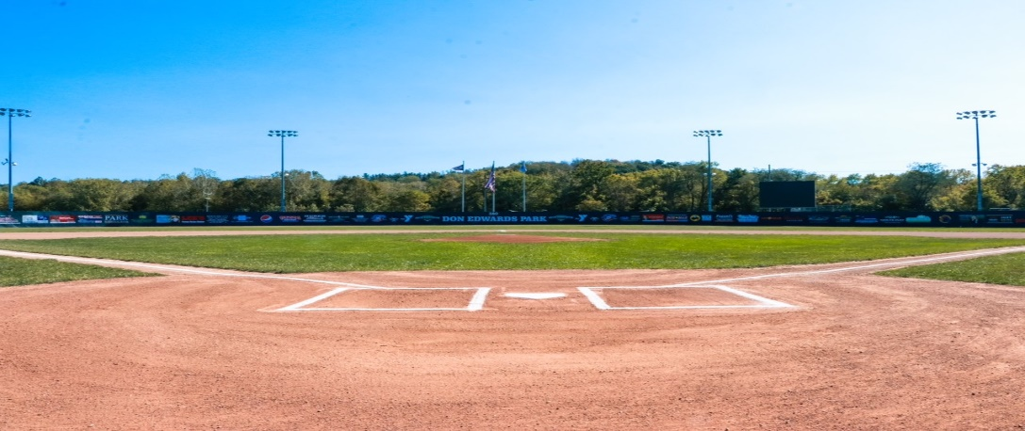

The following guidelines will be enforced in regards to game scheduling.

- In an effort to accommodate all the requested game slots while also allowing adequate time for staff to clean and disinfect in between games all games must be scheduling in the following time slots.
- 7:30am 5:30pm
- 10:00am 8:00pm (LMH and McDonalds Field only)
- 12:30pm 10:30pm (LMH and McDonalds Field only)
- 3:00pm
- All game times will follow the following: No new inning after 1:40 and drop dead at 2:10 mark.
- Tournaments Directors will institute rules, if non-they will follow.
- Ties will be permitted in all non-elimination games for tournaments and league play.
- In the event it is an elimination game, the game will resort back to the last fully completed inning. In the event that was also a tie you will resort back innings until the tie is broken.
- Drop dead games will be considered finished and final, regardless of who is leading and the home team.
- Tournament directors must schedule games in “sets” of double headers when applicable. Sets are (7:30 am & 10:00am) (12:30pm & 3:00pm) (5:30pm & 5:30pm) in these sets only the visiting team from each field will rotate in order to cut down the numbers of dugouts needing sanitized.
- Upon completion of their game’s teams will be asked to immediately leave the dugout to allow cleaning before the new team enters.
- Facility gates will only be opened 45 minutes before game time.
- Everyone in the dugout must be exited and it cleaned by Don Edwards staff before a new team enters.
- Games can start up to 30 minutes early on all fields, teams must be present or risk forfeit.
- Tournament directors can request game slots and fields, but Don Edwards Park staff has final decision.
